# Project Design Phase-II Data Flow Diagram

|  |  |
| --- | --- |
| Date | 14 October 2022 |
| Team ID | PNT2022TMID36558 |
| Project Name | Project – PLASMA DONOR APPLICATION |
| Maximum Marks | 4 Marks |

## Data Flow Diagrams:

A Data Flow Diagram (DFD) is a traditional visual representation of the information flows within a system. A neat and clear DFD can depict the right amount of the system requirement graphically. It shows how data enters and leaves the system, what changes the information, and where data is stored.

## Example: [(Simplified)](https://developer.ibm.com/patterns/visualize-unstructured-text/) Flow

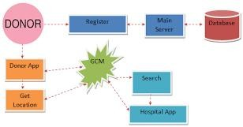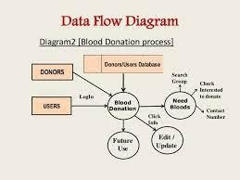

1. [User configures credentials for the Watson Natural Language Understanding](https://developer.ibm.com/patterns/visualize-unstructured-text/) service and starts the app.
2. User selects data file to process and load.
3. Apache Tika extracts text from the data file.
4. Extracted text is passed to Watson NLU for enrichment.
5. Enriched data is visualized in the UI using the DS.js library.

# Stories

|  |  |  |  |  |  |  |
| --- | --- | --- | --- | --- | --- | --- |
| **User Type** | **Functional Requirement**  **(Epic)** | **User Story Number** | **User Story / Task** | **Acceptance criteria** | **Priority** | **Release** |
| Customer (Mobile user) | Installation | USN-1 | As a user, I installed the app for day-to-day update and feeds. | My app will be installed on home screen |  |  |
| Customer (Mobile user) |  | USN-2 | As a user, I can register for the application by entering my email, password, confirming my password and phone  number. | I can access my account / dashboard | High | Sprint-1 |
|  |  | USN-3 | As a user, I will receive conformation  email once I have registered for the application | I can receive  conformation email & click confirm | High | Sprint-1 |
|  |  | USN-4 | As a user, I can register for the application through Gmail | I can register & access the dashboard with Gmail  account Login | Medium | Sprint-1 |
|  | Login | USN-5 | As a user, I can log into the application by entering email & password | I can login to the official  page | High | Sprint-1 |
|  | Dashboard | USN-6 | An open-source app that helps in connecting patients and plasma  donors.This is a beginner friendly repository that helps. | I can access my dashboard | High | Sprint-1 |
| Customer (Web user) | Browsing | USN-7 | Enter the web site on the browser | I can even login through browser | Medium | Sprint-1 |